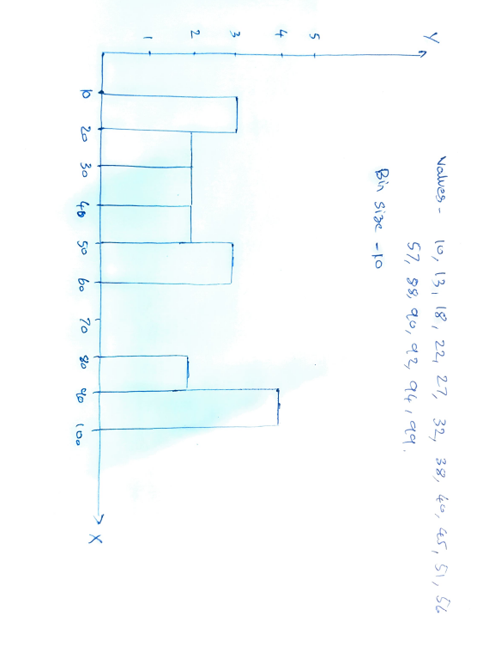Que 1 ) Plot a histogram- 10, 13, 18, 22, 27, 32, 38, 40, 45, 51, 56, 57, 88, 90, 92, 94, 99

Q2.) In a quant test of the CAT Exam, the population standard deviation is known to be 100. A

sample of 25 tests taken has a mean of 520. Construct an 80% CI about the mean

Ans) σ = 100 , n=25 , $\overline{x}$ =520 , $α=$ 0.20 (CI=80%)

$\frac{α}{2}=0.10$

1. 0.10 =0.9000

Z(0.90)= 1.29 (From Z- Table)

Lower Fence = Point Estimate – Margin of error ( $\overline{x},$- $z_{\frac{α}{2}}$* σ/ $\sqrt{n}$)

Higher Fence = Point Estimate + Margin of Error ( $\overline{x},$ + $z_{\frac{α}{2}}$* σ/ $\sqrt{n}$)

Lower CI =520 –1.29*100/ $\sqrt{25}$ = 494.2

Upper CI =520 +1.29*100/ $\sqrt{25}$ = 545.8

Q3) A car believes that the percentage of citizens in city ABC that owns a vehicle is 60% or less. A sales manager disagrees with this. He conducted a hypothesis testing surveying 250 residents & found that 170 residents responded yes to owning a vehicle.

a) State the null & alternate hypothesis.

b) At a 10% significance level, is there enough evidence to support the idea that vehicle owner in ABC city is 60% or less.

Ans)

a)Null Hypothesis (µ0) =The percentage of vehicles owned by the citizens is not less than 60%

Alternate Hypothesis (µ1) = The percentage of vehicles owned by the citizens is less than 60%

b) n=250 , $α=$ 0.10 (CI=90%) , $\hat{P}$ =170/250 = 0.68 , P0= 60% =0.60

$α/2=$ 0.05

1-0.05 =.0950

**Z(0.950)= 1.65**

Now To find the Z value for Proportion

Z0 = $\frac{\hat{P}-P_{0}}{\sqrt{P0\left(1-P0\right)}/\sqrt{n}}$

=0.68-0.60 / $((\sqrt{0.60\left(1-0.60\right)}$)/15.811)

=**2.581**

So 2.581 >1.65

Hence we reject the Null Hypothesis and accept the Alternate Hypothesis.

Que 4) What is the value of the 99 percentile? 2,2,3,4,5,5,5,6,7,8,8,8,8,8,9,9,10,11,11,12

The Value of 99 percentile

Percentile =Percentile/100 *(n+1)

=99/100 * (20+1)

= 20.79

The value of 99 percentile is 12 (which is the 20th Element in the distribution)

Que 5) In left & right-skewed data, what is the relationship between mean, median & mode? Draw the graph to represent the same.

